Garage Management Project in Salesforce

**Problem Statement:**

Managing a garage's daily operations manually is inefficient and prone to errors. Tracking vehicle repairs, customer details, service schedules, and inventory management requires a robust solution. The traditional system leads to delays, data redundancy, and lacks real-time updates. Implementing a Garage Management System on Salesforce ensures streamlined operations, real-time data management, and efficient customer handling.

**Objective:**

The objective of this project is to build a comprehensive Garage Management System using Salesforce to manage vehicle services, track customer data, handle inventory management, and schedule services effectively. The system aims to provide a seamless user interface, accurate real-time reporting, and improve overall operational efficiency.

**Solution Development Procedure:**

1. Set up Salesforce Developer Environment.2. Create custom objects for Vehicles, Customers, Services, and Inventory.3. Configure page layouts and fields for efficient data entry.4. Implement automation using Process Builder and Workflows.5. Create reports and dashboards for real-time insights.6. Test the application for all possible scenarios.7. Deploy the solution.

**Project Screenshots:**

Screenshot 1: login to Garage management system

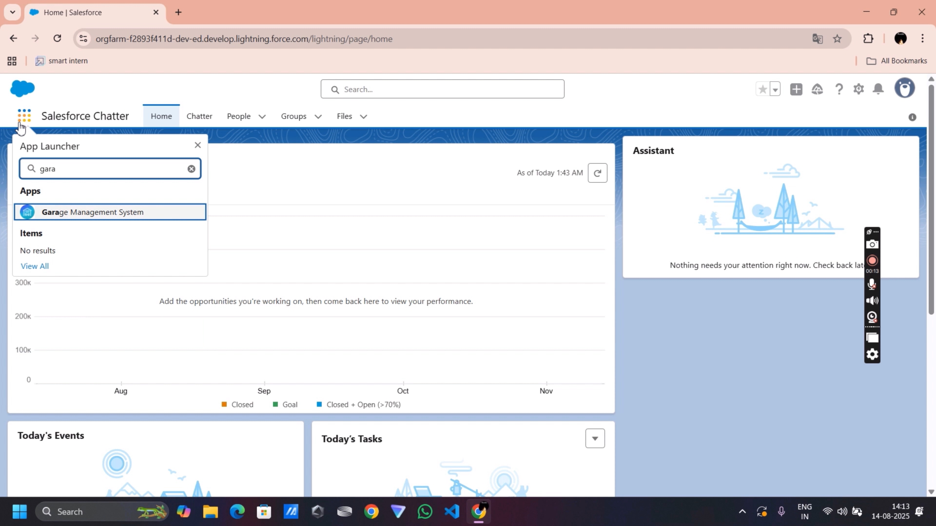

Screenshot 2: customer records management interface

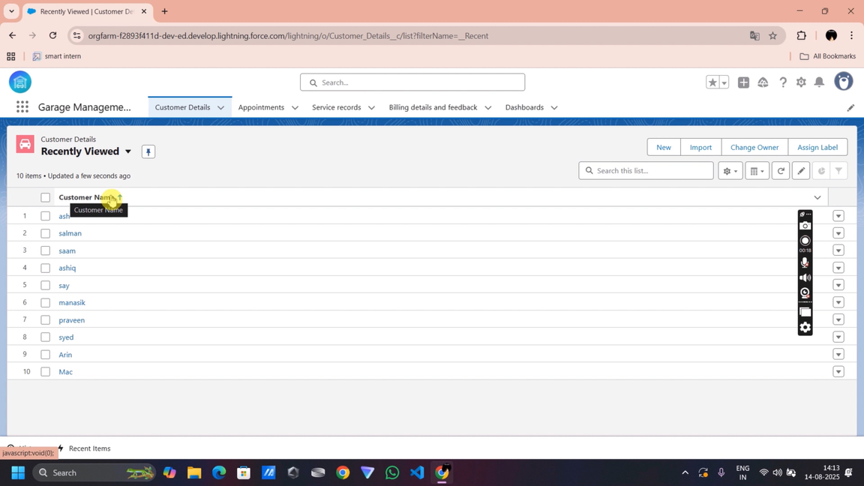

Screenshot 3: customer record create interface

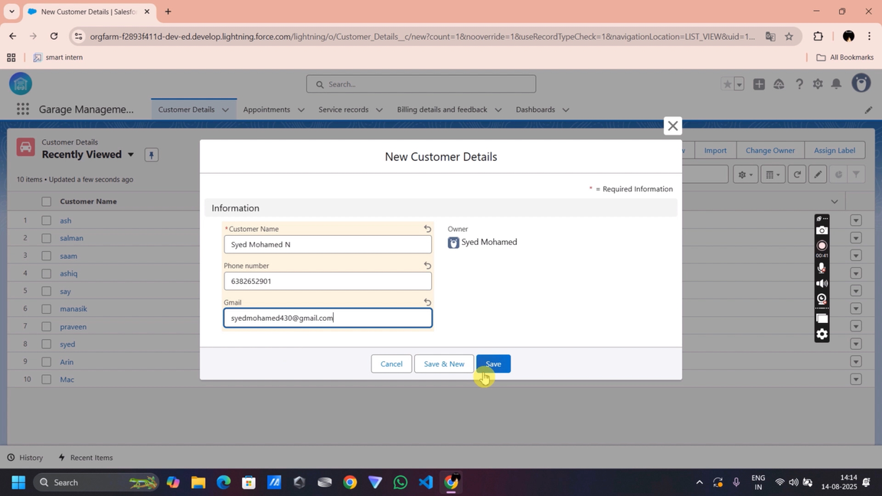

Screenshot 4: appointment record create interface

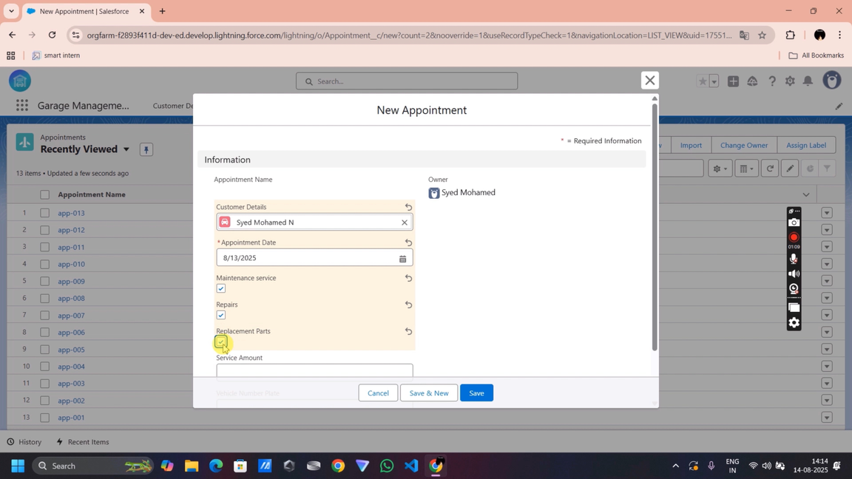

Screenshot 5: service record create interface

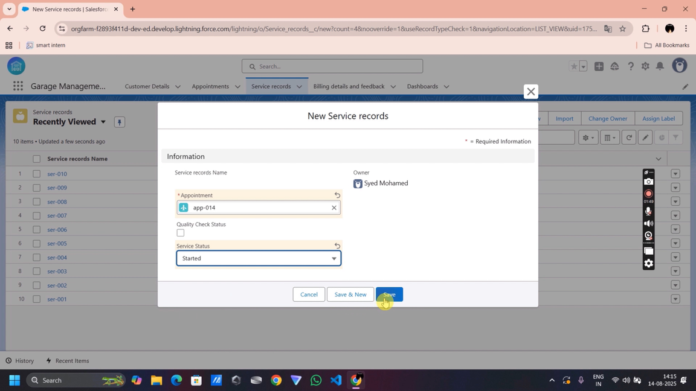

Screenshot 6: billing and feedback interface

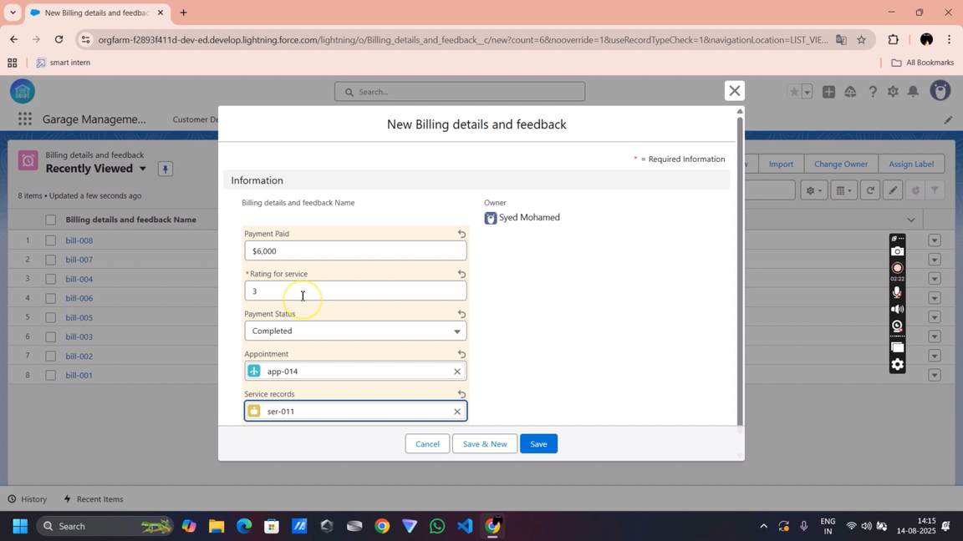

Screenshot 7: dashboard

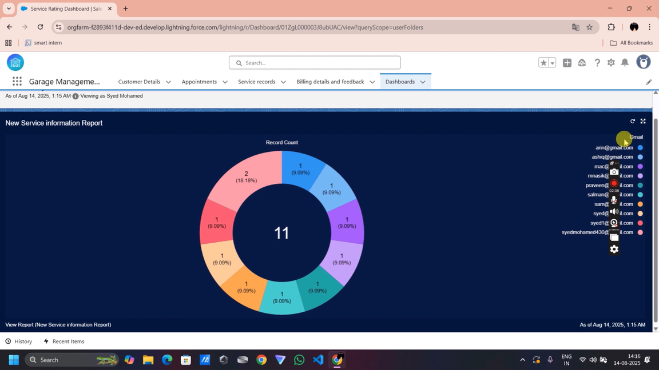

Screenshot 8: automated mail received

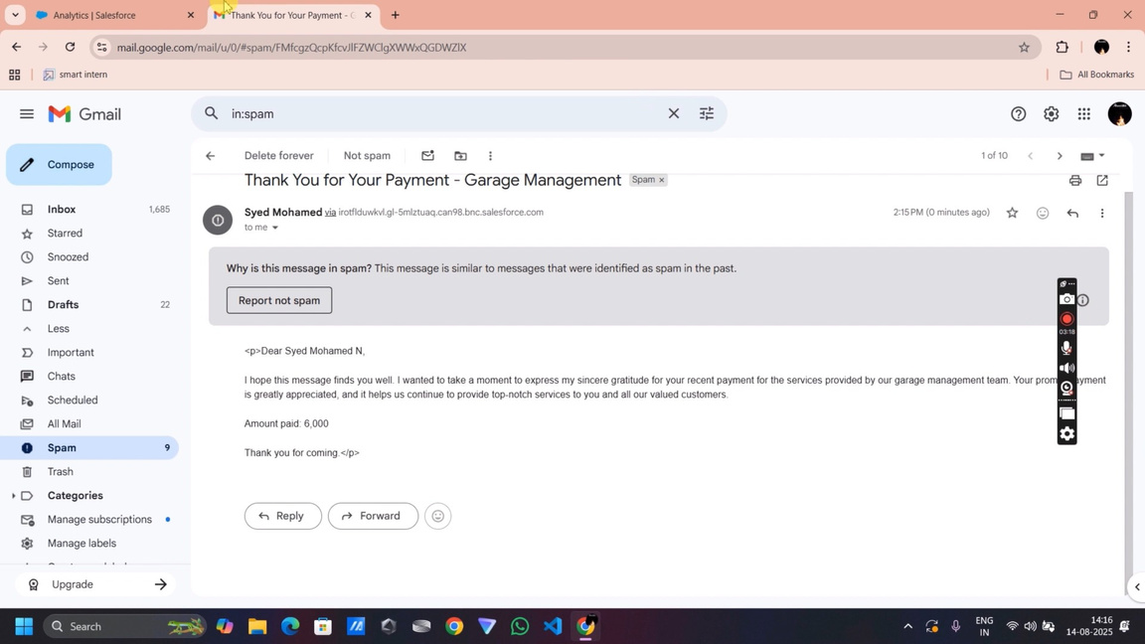

**Conclusion:**

The Garage Management System developed using Salesforce has effectively addressed the manual operation challenges. By automating data management and providing real-time reports, the system enhances productivity and reduces operational overhead. The solution demonstrates a successful application of Salesforce for business process automation, improving both customer satisfaction and business efficiency.